Last Saturday of the Month Breakfast Ride at Dover, Kansas 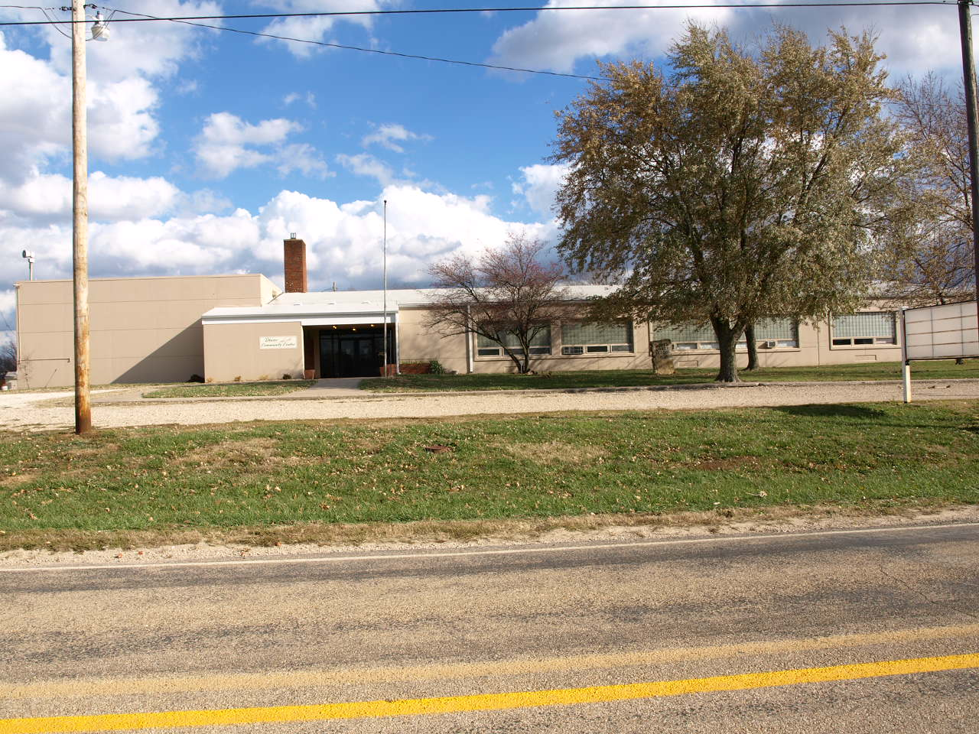 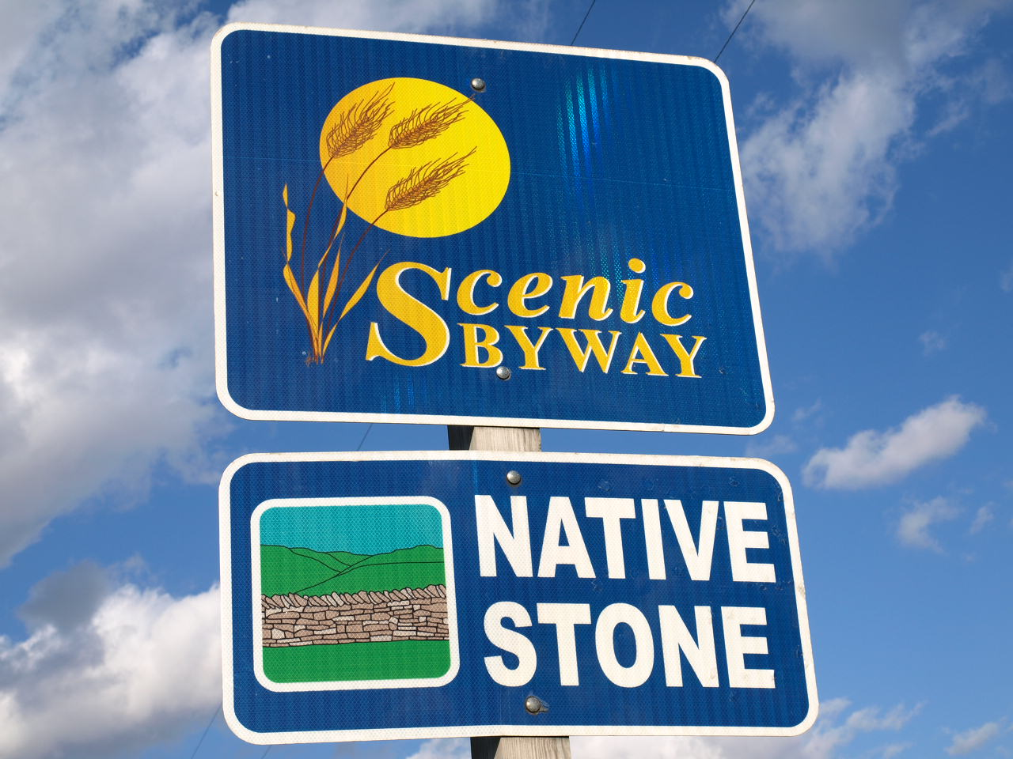
Starting March 29, 2014
Dover Kansas invites you to enjoy Biscuits and Gravy at the Community Center in Dover on the Last Saturday of each month.
B&G: $4.00 Drinks: $1.00
Breakfast will be served from 7:00 AM to Noon.
Sponsored by the Dover Community.

Enjoy riding the scenic Highway K-4 from Topeka through the Flint Hills.
Bikes to look at and people to visit with.
A great meeting place for a Saturday ride.

